File reference: https://github.com/khtsai/Lab/tree/master/Lab1

**Lab Exercise 1**

Step:

1. Go to Apache website to download the installation
2. Move Apache24 folder to C:\ as it prompts error message to show the default root should be located at C:\
3. Open command prompt and go to bin folder to run httpd.exe
4. Open Google chrome and enter <http://localhost> on url bar (the default port is 80)
5. The web page shows “It Works!” as below:

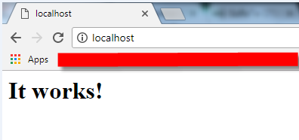

1. Go to htdocs folder and modify index.html
2. Customize some html tag as below:

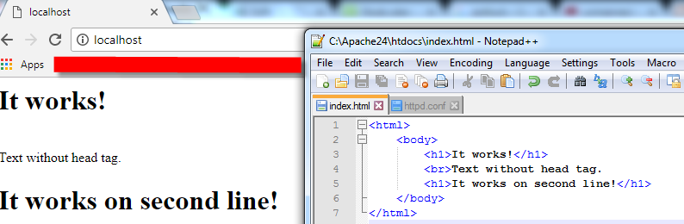

1. Go to conf folder and open httpd.conf
2. Ctrl+F to find “Listen” and modify the port number from 80 to 8888 as the exercise requested.
3. Restart the Apache server and refresh the page by adding :8888 after the localhost

Problem: in step 2, firstly, I put the extracted folder in somewhere but C:\, so the apache server cannot be executed successfully in the beginning. The solution is to google the setting document and found it is located at C:\.

**Lab Exercise 2**

1. Go to cgi-bin folder and create a file called Lab2.cpp
2. In Lab2.cpp, I wrote a class to get and set rows, a char pointer to fetch get http request, some printf to print out the html tag, such as <title> and <table>, and a for loop to dynamically print out <tr> and <td> to show different rows in a table
3. As I don’t have a complier to compile my cpp file, so go to download gcc.exe
4. Open command prompt, move to cgi-bin folder, and run this command “g++ Lab2.cpp -o Lab2.cgi”
5. Run Apache server and enter this url <http://localhost:8888/cgi-bin/Lab2.cgi?Input=10> on Google chrome
6. Then you shall see 10 rows in a table.

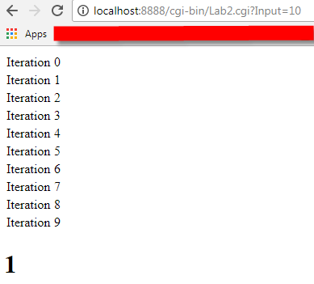

1. The bottom of above image displays “1” which means your url having ONE variable. For instance, if your url after “?” mark like this ?Input1=10&Input2=5, the number will be changed from 1 to 2 because you put two variable in your get request. In addition, since my C++ code is fetching Input as a variable to loop the rows of the table, in this example, you won’t see the table.

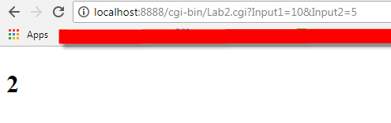

Problem1: cannot compile the cpp code. Solution1: change executed file from gcc to g++ to compile cpp file.

Problem2: cannot use dynamic input number. Solution2: using C++ CGI Variable Wrapper to achieve.